Chapter 03: Financial Accounting

Exercise 03-02: FI Process

Multiple Company Code

Version 4.12

Revised 8/8/2014

Introduction

General Notes and Information

It is strongly recommended that you read through the entire exercise prior to starting. Not all instructions can be provided in a linear manner in the exercise itself. READ CAREFULLY!

The following symbols are used to indicate important information as described below.

* An arrow highlights an important instruction that must not be overlooked.

🖉 A pencil prompts you to write down an important piece of information.

Each student or group will be assigned a unique two-digit identifier. This identifier is used in all exercises. Whenever you see ##, replace it with your identifier. For example, Joe may have an identifier of 05. Every time Joe sees the ## symbol, he will replace it with “05”.

* Always work with your data.

Business Process Overview

The financial accounting process allows GBI to pay vendors for services or materials acquired. This process can be used to pay for liabilities that GBI has incurred due to normal operations.

The exercise is about paying off liabilities within the accounting statements.

Exercise Prerequisites

There are no prerequisites needed.

Exercise Workflow

Exercise Deliverables

Deliverables are consolidated into one worksheet at the end of the exercise. It is only necessary to turn in that worksheet and that worksheet alone along with data in the system if required.

For this exercise you will need the following deliverables:

In the System:

* Journal Entries

On Paper:

* Answer(s) to Question(s)
* Document Number(s)
* You may be assigned additional deliverables. Make certain to check with your instructor.

Step 1: Invest into GBI

In this step, an outside investor invests $60,000 into GBI. You must record this transaction in GBI’s books within SAP. You will credit $60,000 to GBI’s common stock (shareholder equity) account and debit the same amount to GBI’s bank account within the SAP system.

1. In the “SAP Easy Access” screen, follow the navigation path below:

Navigation

Accounting 🡪 Financial Accounting 🡪 General Ledger 🡪 Posting 🡪 Enter G/L Account Document

1. What is the transaction code to post a journal entry? FB50 🖉

* You may be required to enter in your company code.
* If you are not asked to enter in your company code and the transaction does not say your company code at the top of the screen, you can change the current company code to yours by clicking on Edit and then Change Company Code at the top of the screen.

1. You are in the “Edit G/L Account Document: Company Code US##” screen. Enter the following information:

|  |  |
| --- | --- |
| Field Name | Data Entry |
| Document Date | Current Date |

1. At the bottom of the screen, enter the following information:

|  |  |  |
| --- | --- | --- |
| Field Name | Data Entry (Line 1) | Date Entry (Line 2) |
| G/L acct | Your Bank Account | Your Common Stock |
| D/C | Debit | Credit |
| Amount in doc. curr. | 60000 | 60000 |

1. Click on  (ENTER).

* Notice the status light  will turn to green when done correctly.

1. Click on  (SAVE).

You will receive a message that says “Document was posted in company”.

1. What is the resulting document number? 100000000 🖉
2. What type of document is this? G/L Account Document 🖉

* Hint: View the top of the screen for the type of document.

Exercise Deliverables

In the System:

* Journal Entries

On Paper:

* Answer(s) to Question(s)
* Document Number(s)

Step 2: View Account Balances

In this step, you view the account balance of the posting you have made in the previous step.

1. In the “SAP Easy Access” screen, follow the navigation path below:

Navigation

Accounting 🡪 Financial Accounting 🡪 General Ledger 🡪 Account 🡪 Display Balances (New)

1. What is the transaction code to view account balances? FAGLB03 🖉
2. You are in the “G/L Account Balance Display” screen.

Enter the following information:

|  |  |
| --- | --- |
| Field Name | Data Entry |
| Account Number | Your Bank Account |

* Hint: To search for your bank account number, click on the  icon or press on the “F4” key while having your cursor in the field. When searching for the account, make sure that you search through YOUR chart of accounts (GL##) and increase the number of hits possible.

1. Click on  (EXECUTE).
2. What is the general ledger account number for your bank account? 100000 🖉
3. What is the account document currency? USD 🖉
4. What is the current balance for your bank account? 60000 🖉
5. In the “Balance Display: G/L Accounts for the Ledger OL” screen, double- click on the balance (at the bottom right under the “Cum. balance”).

* The following screen lists all of the transactions for the selected month. The “DocumentNo.” column breaks down all of the changes in your bank account by separate transactions.

1. You are in the “G/L Account Line Item Display G/L View” screen.

Select the only document within the chart by placing a check mark.

1. Click on  (DISPLAY).
2. In the “Display Document: Line Item 001” screen, click on the 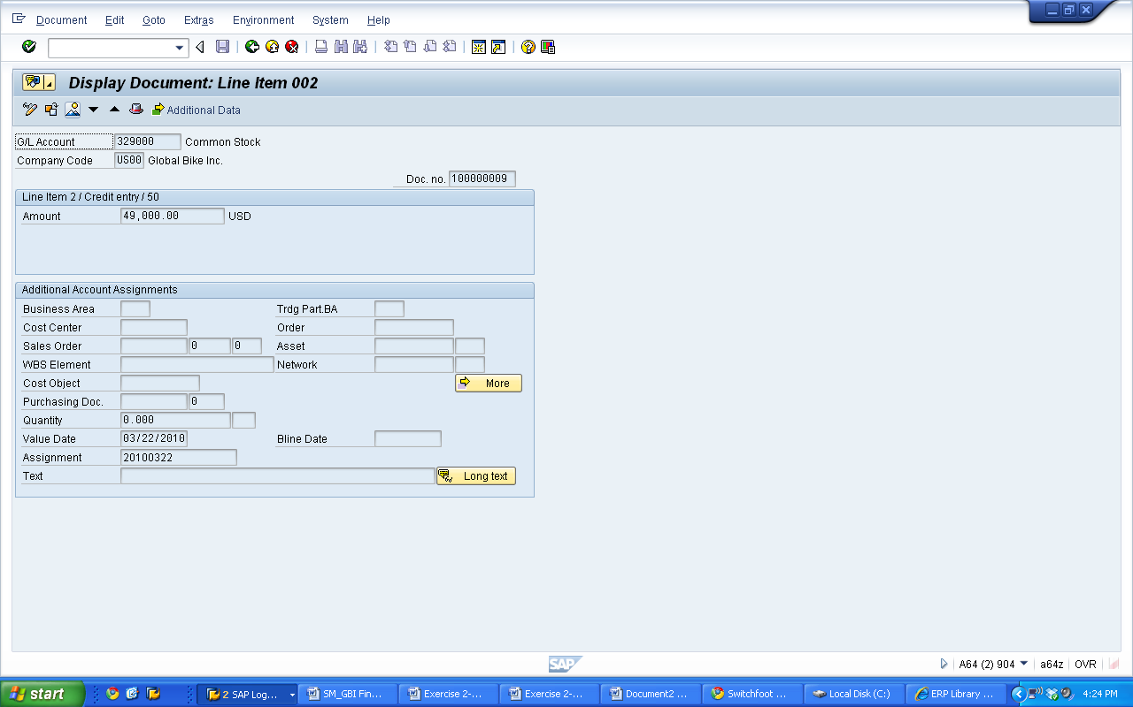 icon.

* Pressing on the F9 key will also call up the document overview.
* This will let you view the journal entries. Two fields to the left of the account number is the posting key field. The posting key describes the type of transaction (expense, credit memo, stock initial entry, etc.) that is entered into a line item during accounting document creation.
* The document overview will bring up a screen or page that will display the accounts used by the document from Step 1 and indicate how they are affected by this transaction when posted.

1. How many accounts are being affected within this transaction? 2 🖉
2. Which period did this transaction take place in? 10 🖉
3. What does Posting Key 40 stand for? Debit Entry 🖉
4. What does Posting Key 50 stand for? Credit Entry 🖉
5. What account is being debited? Bank 🖉
6. What account is being credited? Common Stock 🖉

Exercise Deliverables:

In the System:

* None

On Paper:

* Answer(s) to Question(s)

Step 3: Purchase Supplies for Cash

In this step you purchase supplies. Because it is a cash transaction GBI will not assume liability.

1. In the “SAP Easy Access” screen, follow the navigation path below:

Navigation

Accounting 🡪 Financial Accounting 🡪 General Ledger 🡪 Posting 🡪 Enter G/L Account Document

1. What is the transaction code to purchase supplies with cash? FB50 🖉
2. You are in the “Enter G/L Account Document: Company Code US##” screen.

Enter the following information:

|  |  |
| --- | --- |
| Field Name | Data Entry |
| Document Date | 20th of the Current Month |
| Posting Date | 20th of the Current Month |

1. At the bottom of the screen, enter the following information:

|  |  |  |
| --- | --- | --- |
| Field Name | Data Entry (Line 1) | Date Entry (Line 2) |
| G/L acct | Your Supplies Expense | Your Bank Account |
| D/C | Debit | Credit |
| Amount in doc. curr. | 500 | 500 |
| Cost center | Your Admin Costs | (leave blank) |

* Look for your administration costs by using your identifier.

1. Click on  (ENTER).

* A yellow warning message may occur about a future date. If this should happen, click on the  icon to continue. Keep this in mind for the following steps for the rest of this exercise.

1. Click on  (SAVE).

You will receive a message that says “Document was posted in company”.

1. What is the resulting document number? 100000002 🖉

* Review your supplies expense and your bank account to answer the following questions for this exercise while using transaction FB03. While in this screen another document can be viewed by going to Document (on the very top of the screen), then “Other Document… (Shift+F5).”
* As previously stated, the following information may also be found by displaying the balances, then breaking down to the individualized transactions.

1. What is the general ledger account number for your supplies expense? 740000 🖉
2. What is the general ledger account number for your bank account? 100000 🖉
3. What is the posting key for your supplies expense? 40 🖉
4. What is the posting key for your bank account? 50 🖉

Exercise Deliverables:

In the System:

* Journal Entries

On Paper:

* Answer(s) to Question(s)
* Document Number(s)

Step 4: Purchase Supplies via Payables - Misc.

In this step, GBI purchases supplies via payables-miscellaneous and then pays for them at a later date from its bank. This is a two-step process: receive the supplies and pay for them later.

1. In the “SAP Easy Access” screen, follow the navigation path below:

Navigation

Accounting 🡪 Financial Accounting 🡪 General Ledger 🡪 Posting 🡪 Enter G/L Account Document

1. What is the transaction code to purchase supplies via payables–misc.? FB50 🖉
2. You are in the “Enter G/L Account Document: Company Code US##” screen.

Enter the following information:

|  |  |
| --- | --- |
| Field Name | Data Entry |
| Document Date | 10th of the Current Month |
| Posting Date | 10th of the Current Month |

1. At the bottom of the screen, enter the following information:

|  |  |  |
| --- | --- | --- |
| Field Name | Data Entry (Line 1) | Date Entry (Line 2) |
| G/L acct | Your Supplies Expense | Your Payables-Misc. |
| D/C | Debit | Credit |
| Amount in doc. curr. | 500 | 500 |
| Cost center | Your Admin Costs | (leave blank) |

1. Click on  (ENTER).
2. Click on  (SAVE).

You will receive a message that says “Document was posted in company”.

1. What is the resulting document number? 100000007 🖉

* Refer to a previous exercise on how to review account balances. Review your supplies expense and your payables-misc. account to answer the following questions for this exercise.

1. What is the general ledger account number for your supplies expense? 740000 🖉
2. What is the general ledger account number for your payables-miscellaneous? 300200 🖉
3. What is the posting key for your supplies expense? 40 🖉
4. What is the posting key for your payables-miscellaneous? 50 🖉
5. Which period did this transaction take place in? 10 🖉

* Refer previously on how to get back to posting an accounting document to your ledger.

1. Enter the following information:

|  |  |
| --- | --- |
| Field Name | Data Entry |
| Document Date | 15th of the Current Month |
| Posting Date | 15th of the Current Month |

1. At the bottom of the screen, enter the following information:

|  |  |  |
| --- | --- | --- |
| Field Name | Data Entry (Line 1) | Date Entry (Line 2) |
| G/L acct | Your Payables-Misc. | Your Bank Account |
| D/C | Debit | Credit |
| Amount in doc. curr. | 500 | 500 |

1. Click on  (ENTER).
2. Click on  (SAVE).

You will receive a message that says “Document was posted in company”.

1. What is the resulting document number? 100000008 🖉

* Refer to a previous exercise on how to review account balances. Review your payables-misc. account and your bank account to answer the following questions for this exercise.

1. What is the posting key for your bank account? 50 🖉
2. What is the posting key for your payables-miscellaneous? 50 🖉
3. Which period did this transaction take place in? 10 🖉

Exercise Deliverables:

In the System:

* Journal Entries

On Paper:

* Answer(s) to Question(s)
* Document Number(s)

Step 5: Pay Rent

In this step, GBI pays the rent on its building for the current month and prepays the rent for the following two months. You must record this transaction in GBI’s books. GBI pays $5,000 per month so you need to pay a total of $15,000 from GBI’s cash account. You must debit the current month’s rent using the rent expense account and assign it to the cost center for administrative costs. You must then debit the payment for the next two months of the year.

The second part of this exercise step simulates the journal entry that will be made the following month when GBI’s rent payment is due. The bank does not receive the payment when you prepay rent, the landlord does. The reason that prepaid rent is debited is because of the matching principle in accounting. The prepaid account is credited when the expense is accrued.

1. In the “SAP Easy Access” screen, follow the navigation path below:

Navigation

Accounting 🡪 Financial Accounting 🡪 General Ledger 🡪 Posting 🡪 Enter G/L Account Document

1. What is the transaction code to pay rent? FB50 🖉
2. You are in the “Edit G/L Account Document: Company Code US##” screen.

Enter the following information:

|  |  |
| --- | --- |
| Field Name | Data Entry |
| Document Date | Last Day of the Current Month |
| Posting Date | Last Day of the Current Month |

1. At the bottom of the screen, enter the following information:

|  |  |  |  |
| --- | --- | --- | --- |
| Field Name | Line 1 | Line 2 | Line 3 |
| G/L acct | Your Pre Rnt. | Your Rent Expense | Your Bank |
| D/C | Debit | Debit | Credit |
| Amount | 10000 | 5000 | 15000 |
| Cost center | (leave blank) | Your Admin Cost | (leave blank) |

1. Click on  (ENTER).
2. Click on  (SAVE).

You will receive a message that says “Document was posted in company”.

1. What is the resulting document number? 100000005 🖉

* Refer to a previous exercise on how to review account balances. Review your prepaid rent, your rent expense, and your bank account to answer the following questions for this exercise.

1. What is the general ledger account number for your prepaid rent? 215000 🖉
2. What is the general ledger account number for your rent expense? 740300 🖉

* Refer previously on how to get back to posting an accounting document to your ledger.

1. You are in the “Edit G/L Account Document: Company Code US##” screen. Enter the following information:

|  |  |
| --- | --- |
| Field Name | Data Entry |
| Document Date | Last Day of the Next Month |
| Posting Date | Last Day of the Next Month |

1. At the bottom of the screen, enter the following information:

|  |  |  |
| --- | --- | --- |
| Field Name | Data Entry (Line 1) | Data Entry (Line 2) |
| G/L acct | Your Rent Expense | Your Prepaid Rent |
| D/C | Debit | Credit |
| Amount in doc. curr. | 5000 | 5000 |
| Cost center | Your Admin Costs | (leave blank) |

1. Click on  (ENTER).
2. Click on  (SAVE).

You will receive a message that says “Document was posted in company”.

1. What is the resulting document number? 100000006 🖉

Exercise Deliverables:

In the System:

* Journal Entries

On Paper:

* Answer(s) to Question(s)
* Document Number(s)

Attachment 1: Exercise Worksheet

**Name:** P.Chaitanya Swaroop

**Course and Section:** OMIS 643

**Identifier:** GBI-033

**Client:** 725

1. What is the transaction code to post a journal entry? FB50 🖉
2. What is the resulting document number? 100000000 🖉
3. What type of document is this? G/L Account Document 🖉
4. What is the transaction code to view account balances? FAGLB03 🖉
5. What is the general ledger account number for your bank account? 100000 🖉
6. What is the account document currency? USD 🖉
7. What is the current balance for your bank account? 60000 🖉
8. How many accounts are being affected within this transaction? 2 🖉
9. Which period did this transaction take place in? 10 🖉
10. What does Posting Key 40 stand for? Debit Entry 🖉
11. What does Posting Key 50 stand for? Credit Entry 🖉
12. What account is being debited? Bank 🖉
13. What account is being credited? Common Stock 🖉
14. What is the transaction code to purchase supplies with cash? FB50 🖉
15. What is the resulting document number? 100000002 🖉
16. What is the general ledger account number for your supplies expense? 740000 🖉
17. What is the general ledger account number for your bank account? 100000 🖉
18. What is the posting key for your supplies expense? 40 🖉
19. What is the posting key for your bank account? 50 🖉
20. What is the transaction code to purchase supplies via payables–misc.? FB50 🖉
21. What is the resulting document number? 100000007 🖉
22. What is the general ledger account number for your supplies expense? 740000 🖉
23. What is the general ledger account number for your payables-miscellaneous? 300200 🖉
24. What is the posting key for your supplies expense? 40 🖉
25. What is the posting key for your payables-miscellaneous? 50 🖉
26. Which period did this transaction take place in? 10 🖉
27. What is the resulting document number? 100000008 🖉
28. What is the posting key for your bank account? 50 🖉
29. What is the posting key for your payables-miscellaneous? 50 🖉
30. Which period did this transaction take place in? 10 🖉
31. What is the transaction code to pay rent? FB50 🖉
32. What is the resulting document number? 100000005 🖉
33. What is the general ledger account number for your prepaid rent? 215000 🖉
34. What is the general ledger account number for your rent expense? 740300 🖉
35. What is the resulting document number? 100000006 🖉